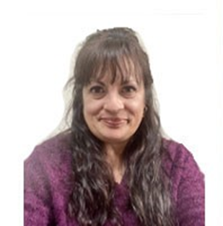
Kirsten Peterson
Director, Our Brother’s Keeper

Kirsten Marie Peterson has a Master's Degree in Special Education, and a Bachelor's Degree in Visual Disabilities. She worked as a special education teacher for twenty-five years in a variety of districts in FL, GA and IL. She also taught karate in IL for several years, before choosing to work from home as an entrepreneur/writer and later as a caretaker of her granddaughter. Kirsten is mom to five children, all of whom still live at home.
Kirsten has been dedicated to the work of Our Brothers’ Keepers of Southern Illinois (OBK) for many years. Her late brother, Russell Peterson, was OBK’s first Board President. Prior to becoming the Agency Director at OBK in 2023, Kirsten was a Board Member. Kirsten brings enthusiasm, commitment, intelligence, and compassion to our mission to serve the Returning Citizens of Saint Clair County IL
.

